The architecture model consists of eight main features: the User Interface, User Account Manager, Matchup Choice Screen, Graph Generator, Prediction Model, Administration Panel, Football Data API, and Database.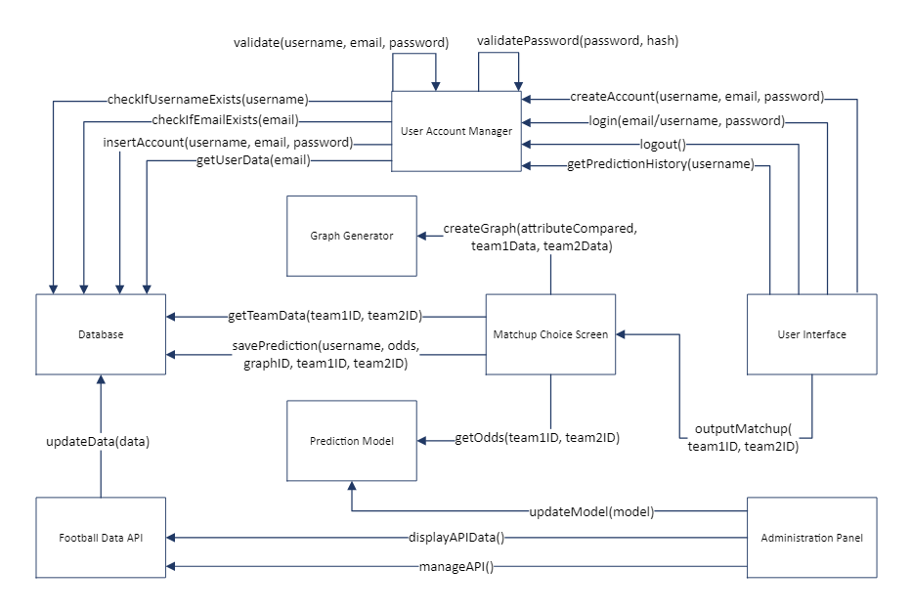

The User Interface allows the user to sign in/up and log out, and it connects directly to the User Account Manager. The User Account Manager then validates the account and password and connects with the Database to check if the username/email has already been used, add an account to the database, and retrieve saved user data.

The user interface also enables the user to predict matchup odds and analysis by inputting two teams into the Matchup Choice Screen. The screen retrieves data on the two teams from the Database and sends it to the Graph Generator, which creates a graph based on predetermined comparisons. The odds for the matchup are calculated by sending the team IDs to the Prediction Model, which predicts the odds and sends them back to the user interface along with the created graphs.

Finally, the Administration Panel allows the owners of the app to regularly update the statistical model and view and manage the Football Data API. The API regularly updates the Database with football data.